Муниципальное образовательное учреждение
«Средняя общеобразовательная школа №1»
Г. Мензелинск Республика Татарстан

Museum of youth subcultures

Проектная работа
учениц 10 класса
Игнатьевой Лили,
Набиевой Наили
Руководитель: Янова Л.С.
Учитель иностранного языка

г. Мензелинск 2008г.
Содержание

- Введение………………………………………………………………....3
- History of subcultures in the 20th century…………………….................6
- How do Teens express their Individuality today......................................18
- What do elderly and middle- aged persons think about teenagers…………………………………………………………...........23
- What think teenagers about them…………………………….................24
- Our ideas……………………………………………………..................24
- Заключение…………………………………………………………….27
- Список используемой литературы…………………………………...28
- Приложение………………………………………………………........29

Введение
Молодежь, взрослея, приходит уже не в тот мир, к которому ее готовили в процессе социализации. Опыт старших не годится. Молодых готовили к занятию одних позиций в социальной структуре, а структура уже другая, тех позиций в ней нет.
Новое поколение ступает в пустоту. Не они выходят из социальной структуры общества, а сама структура ускользает из-под ног. Здесь и начинается бурный рост молодежных субкультур, отталкивающих от себя мир взрослых, их ненужный опыт. И результат пребывания в лоне субкультуры уже другой: не встраивание в прежнюю структуру, а СТРОИТЕЛЬСТВО НОВОЙ…
М. Мид
Недавно нам в руки попала статья, в которой говорилось об организации в МГПИ медиа-центра “Музей Молодежных Субкультур”. Создан он был совместными усилиями студентов и администрации института. Изначально проект был реализован как небольшая театрализованная постановка к Актовому Дню института. Несколько студентов в костюмах представителей различных субкультур вышли на сцену, сыграли свои роли и ушли, оставив у зрителей чувство некоторой незавершенности — «А что же дальше?». А дальше началась кропотливая работа… После того как мы прочитали эту статью, нам пришла в голову интересная идея создания своего школьного музея молодёжных субкультур. Наверное, каждому из нас случалось идти по улице, ехать в метро или просто смотреть телевизор и видеть людей, которые чем-то непохожи на других. У кого-то на голове ирокез, кто-то весь в металле, а кто-то в черной коже проносится мимо вас на мотоцикле. Чаще всего это и есть неформалы – представители современных субкультур.
Само слово неформал, неформальный обозначает необычность, яркость и незаурядность. Человек–неформал – это попытка показать свою индивидуальность, сказать серой массе: «я – личность», бросить вызов миру с его бесконечными буднями и выстраиванием всех в один ряд. Субкультура - это система ценностей, установок, способов поведения и жизненных стилей, которая присуща более мелкой социальной общности, пространственно и социально в большей или меньшей степени обособленной. Субкультурные атрибуты, ритуалы, а также ценности, как правило, отличаются от таковых в господствующей культуре, хотя с ними и связаны. Английский социолог М.Брейк отмечал, что субкультуры как "системы значений, способов выражения или жизненных стилей" развивались социальными группами, находившимися в подчиненном положении, "в ответ на доминирующие системы значений: субкультуры отражают попытки таких групп решить структурные противоречия, возникшие в более широком социальном контексте". Другое дело культура – массовое явление – присущая большей части общества система ценностей и образ жизни, диктуемый обществом. Все мы похожи и внешне, и по образу жизни, и по своим привычкам. Мы подвергаемся влиянию моды, СМИ, общественному мнению и подчиняемся порядкам. Молодежь, как наиболее чуткая и восприимчивая группа, первой воспринимает новые формы развития в сфере досуга со всеми позитивными и негативными явлениями. Ее не могут до конца удовлетворить существующие общепринятые развлечения и способы провождения времени. И молодежь придумывает свой способ. Раньше в России (Советском Союзе) было больше контроля над молодежью, существовали пионерская организация и комсомол, которые были обязательны, но большинство их членов были пассивными и вступали в них скорее потому, что «так полагалось». На современном этапе молодёжь получила больше свободы для самореализации без постоянного вмешательства со стороны взрослых.
В своей работе мы использовали следующие источники: английский журнал «English.Preparing for Exams» , учебное пособие « Великобритания», учебник по английскому языку для 10-11 классов (а так же к нему приложения), ресурсы Интернета. В каждом из этих источников мы смогли познакомиться с новыми неформальными движениями молодёжных субкультур, узнать мнения окружающих по этому поводу, сделать для себя соответствующие выводы.
Цель работы: предложить создание школьного музея молодёжных субкультур

Задачи:
- рассмотреть историю возникновения молодёжных течений;
- познакомиться с представителями разных течений субкультур;
- рассмотреть мнения подростков о субкультурах;
- узнать отношение к молодёжным течениям людей старшего поколения;
- предложить создание школьного музея молодёжных субкультур.

History of subcultures in the 20th century

The 20th century was a time of social diversity and the rise of the individual. The world wars and revolutions which dominated the first half of the century put a terrible psychological pressure upon the vast majority of people. For instance the war conscriptions meant that enormous numbers of people were put into uniform and thus denied the freedom of individuality in their choice of clothes and hairstyles. In addition there was the threat of death and the loss of friends and loved ones. As a result the 20th century produced a breed of people frantic to live life to the full (before it was taken away) and to express individuality. There seems to be a dynamic relationship between subculture and warfare. Society sends its young, healthy and strong to kill the young, healthy and strong of another society and subculture seems to be provoked through the social trauma which results. There also is a clear relationship between subculture and refugee or immigrant status. Since there is clearly a link between warfare and the creation of refugees and forced exiles a sociological pattern is discernable. Richard Collier's 1984 book The Rainbow People describes a subculture of transatlantic-based wealthy hedonists. He says, "The era of the Rainbow People opened with the coronation of a prince called 'Tum-Tum' as Britain's Edward VII in 1902 and closed in 1975 with the death of Aristotle Onassis, dubbed 'Daddy-O' by Women's Wear Daily." Wealth and class can be considered a subculture although the term is more usually associated with fashion

The early years of the century
In the period before World War I subculture was a small thing, social groupings of hobbyists or a matter of style and philosophy amongst artists and bohemian poets. One continuing 20th century subculture was Nudism. The first known organised club for nudists, Freilichtpark (Free-Light Park), was opened near Hamburg, Germany in 1903. Also in Germany, from 1909 onwards there was the beginning of a movement, mainly of young men and then also young women, toward freedom and getting back to nature. They wanted to throw off the strict rules of society and be more open and natural. They were called Wandervogel which can be translated as "hikers", "ramblers" or perhaps "freebird". In Italy a popular art movement and philosophy called Futurism championed change, speed, violence and machines. Hairstyles at the beginning of the century were not strict unless you were in a religious order or other controlled circumstances (the military or prison etc.). Both men and women regarded long hair as normal. Men and women had, after all, always had long hair, since prehistory.

World War I
Because of the (1914-1918) world war, though, everything changed. The wartime trenches had infestations of lice and fleas. Soldiers had their heads shaved. Consequently men with short hair appeared to have been at the front in the war, while men with long hair might be thought of as pacifists and cowards, suspected of desertion. Some artists managed to avoid the war by sitting it out in neutral Switzerland. A group of artists in Zurich invented Dadaism as an anti-war, anti-art, art movement and a parody of the pro-violent attitudes of Futurism. They became politically active as an underground anarchical attempt to change society's trend toward self-destruction.

The 1920s and 30s
In the 1920s American Jazz music and motor cars were at the centre of a European subculture of freedom and wild living which began to break the rules of social etiquette and the class system. Meanwhile, in America, the same flaming youth subculture was "running wild" but with the added complication of alcohol prohibition. Canada had prohibition in some local areas but where alcohol was permitted thirsty Americans coming over the border found an oasis. Some smuggling was done and this escalated as the crime gangs became organised. In the southern states of the USA Mexico or Cuba were other possible destinations for drinkers. Thus a drinking subculture grew in size and a crime subculture grew along with it. Other drugs existed which could be used as alternatives to alcohol. When prohibition ended the subculture of drink, drugs and jazz didn't go away. Neither did the gangsters. The nudist movement gained prominence in Germany in the 1920s, but was suppressed during the Nazi Gleichschaltung after Adolf Hitler came to power. Social nudism in the form of private clubs and campgrounds first appeared in the United States in the 1930s. In Canada it first appeared in British Columbia about 1939 and in Ontario nine years later.In the art world, the spiritual home of most subcultures, the surrealist movement was attempting to shock the world with their games and bizarre behaviour. The surrealists were at one and the same time a serious art movement and a parody of other art forms and political movements. Surrealism had been developed by Andre Breton and others from the thinking in the Dada movement. Based in several European countries, surrealism was going to run into serious trouble when the Nazis began to take over. Subcultures and "degenerate art" were almost completely stamped out and replaced by the Hitler Youth. In North America the depression caused widespread unemployment and poverty, causing many young people to feel like dead end kids. The phenomenon of the dead end kid was taken into fiction and put on the stage and screen where it proved an enormously popular image with which people could identify. Films featuring The Dead End Kids, The Bowery Boys, Little Tough Guys etc were popular from the 1930s to the 1950s. See external link: The (Unofficial) Bowery Boys' Page (http://boweryboys.bobfinnan.com/). The Dust bowl disaster forced large numbers of rural Americans from Oklahoma and elsewhere to move their entire families to look for some alternative way to continue living. This got them labelled as "Okies" and treated very poorly by the authorities in other states they moved to. The refugee situation was recorded in folk songs (many of them by Woody Guthrie) and in a novel, The Grapes of Wrath by John Steinbeck and a subsequent movie of the book. The movie starred Henry Fonda.

The 1940s
Avant-garde artists like Max Ernst, Marcel Duchamp and Marc Chagall had to flee Europe following the outbreak of World War II. They arrived in the United States and began to make contact with each other. Modern art's new home was in New York City. A subculture of American-based surrealism and avant-garde experimentation became the new centre of the art world. In the 1940s American fashion was still gangster orientated. Gangs gravitated largely around immigrant and racial cultures. In California Hispanic youths developed a fashion recognised by their distinctive zoot suits. The girls dressed all in black and were called Black widows. The zoot suiters use of language used a lot of rhyming and trick words like so-called pig latin (also known as backslang). The whole thing, including Afro-American, Cuban, Mexican and South American elements and bits introduced by Slim Gaillard like McVouty oreeney was collectively known as Swing or Jive talk. See external link: Dictionary of Swing The entry of America into World War II was heralded by a new legislation which made zoot suits illegal because of the extra cloth which they used up. This led to the Zoot Suit Riots. In Europe black-marketers prospered under the rationing. Clothing styles depended on what could be begged or acquired by some means, not necessarily legal. There were restrictions everywhere. When the Americans arrived in Britain, black-marketers did deals with GIs for stockings, chocolate, etc. Inevitably, subculture continued to have an image of criminality and the brave, the daring, the milieu, the resistance, etc. The black market in drugs thrived just about anywhere. British black-marketers were sometimes called Wide boys. After the second war the zoot suit craze spread to France in the form of the Zazou youths. Meanwhile the intellectuals in France were forming an existentialist subculture around Jean Paul Sartre and Albert Camus in Paris cafe culture. In post-war America folk songs and cowboy songs (also known, in those days, as hillbilly music) were beginning to be more popular with a wider audience. A subculture of rural jazz and blues fans had blended elements of jazz and blues into traditional cowboy and folk song styles to produce a crossover called western swing. This type of music was able to spread across America in the 40s thanks to the prevalence of radio. Radio was the first almost instantaneous mass media and had the power to create large subcultures by spreading the ideas of a small subculture across a wider area. A new jazz subculture formed from the rebellion of some musicians against the melodic styling of swing. Their rebellion produced Bebop and the early players of it included Dizzy Gillespie and Charlie Parker. The subculture which formed around this kind of jazz was the beginning of Hipsters and the Beat generation.
In 1947, the same year that Jack Kerouac made his epic journey across America which he would later describe in On the Road and the same year as the occurrence at Roswell, New Mexico which was claimed as a UFO crash, there was an incident involving a motorcycle gang at Hollister, California. A story about the incident was published that year in Harper's Magazine and would be developed (6 years later in 1953) as the Marlon Brando film The Wild One. A year after the incident the Hells Angels (without the apostrophe), formed in 1948 in Fontana, California. The name Hells Angels had been used as a movie title by Howard Hughes ten years before. The Hells Angels began as a motorcycle club looking for excitement in the dull times after the end of the war. They became far more notorious as time went on. Motorcycle gangs in general began to hit the headlines.

The 1950s
The Existentialists had a profound influence upon subcultural development. The emphasis on freedom of the individual influenced the beats in America and Britain and this version of existential bohemianism continued through the 1950s and into the 60s under the guise of the beat generation. Beards and longer hair returned in another attempt at returning to the image of peacetime man and the normality which had existed before the two wars. At the same time, as a result of American post-war prosperity, a new identity emerged for youth subculture: the teenager. Jazz culture was transformed, by way of Rhythm and Blues into Rock and Roll culture. At the same time, jazz culture itself continued but changed into a more respected form, no longer necessarily associated with wild behaviour and criminality. From the 1950s onward society noticed an increase in street gang culture, random vandalism and graffiti. Sociologists, psychologists, social workers and judges all had theories as to what was causing the increase to urban trouble but the consensus has generally tended to be that the modern urban environment offers all the bright lights and benefits of the modern world but often provides working class youths with little in reality. This theory and others were parodied in the musical West Side Story (based on Shakespeare's Romeo and Juliette) in song lyrics such as Jet Song, America, and Gee, Officer Krupke. As American rock and roll arrived in the United Kingdom a subculture grew around it. Some of the British post-war street youths hanging around bombsites in urban areas and getting drawn into petty crime began to dress in a variation of the zoot suit style called a drape suit with a country style bootlace tie, winkle picker shoes, drainpipe trousers, and Elvis Presley style slicked hair. These youths were called Teddy boys. Their girlfriends would usually wear, for a night out dancing at the palais, the same sort of poodle skirts and crinolines their counterparts in America would wear. For day-to-day wear there was a trend toward girls wearing slacks or jeans. At the time the idea of girls wearing trousers and boys taking time over their hairstyle was socially shocking to many people. British youth divided into factions. There were the modern jazz kids, the trade jazz kids, the rock and roll teenagers and the skiffle craze. Coffee bars were a meeting place for all the types of youth and the coolest ones were in Soho, London. In Britain, the political side of the Beat Generation was the anti-nuclear movement led by CND. Ban the Bomb marches became a very recognisable British social phenomenon. In America and Australia, Hawaiian-influenced Surfing was the new youth sport. A whole subculture grew around the sport and the associated parties, clothes, speech patterns and music. During the same timeframe skateboard riding developed as a parallel lifestyle to wave riding. Both forms of board riding continued throughout the remainder of the century and into the next. From these two sports young people learned to provide their own social structure within which they could display skills and excellence.

The 1960s

In the 1960s the "beats" or "beatniks" grew to be an even larger subculture, reaching such proportions that they spread around the world, and developed subcultures of their own. Subcultures within subcultures. That was the extent of cultural fractiousness in the 60s. The beat scene included Radicals, Peaceniks, Mods, Rockers, Bikers, hippies and, eventually, the self-parody thing: the freak scene. The term mod had different meanings depending which side of the Atlantic you were on and so did radical. Subcultures were still usually about living life to the full and wild behaviour but in the 60s there was the Vietnam war to protest about, rebel against and avoid getting drafted into. The hippies' big year was 1967, the so called summer of love. There were subcultures which were also political movements, for instance the Black Panther Party and the Yippies. University students around the world had always been a minor subculture but, by the mid-60s, had become a major one. In Paris, France in May 1968 a student uprising brought the country to a standstill and caused the government to call a general election rather than run the risk of being toppled from power. Also during the 60s was the beginning of Hacker culture from the increased usage of computers at colleges. Students who were fascinated by the possibilities of computers, the telephone and technology in general began figuring out ways to make the technology more freely available or accessible. Another subculture of the 60s was the Rude boy culture in Jamaica and, latterly in the United Kingdom. The rude boy subculture influenced some elements of the British mods, which then developed into skinheads around 1969.

The 1970s
In the 1970s the hippie, mod and rocker cultures were in a process of transformation which temporarily took on the name of freaks (openly embracing the image of strangeness and otherlyness). A growing awareness of identity politics combined with the legalisation of homosexuality and a huge amount of interest in science fiction and fantasy forms of speculative writing produced the autre with an attitude freak scene. There was a lot of talk about "revolution", most of which was, undoubtedly, a lot of talk. At some stage, though it's unclear when, some of the hacker/computer nerd subculture took on the derogatory word geek with pride, in the same way the freaks had done. Computer usage was still a very inaccessible secret world to most people in those days but lots of people were interested in computers because of their appearance in science fiction. The dream of one day owning a computer was a popular fantasy amongst science fiction fandom which had grown from a minor subculture in the first half of the 20th century to a quite large contingent by the 70s, along with horror fandom, comics fandom and fantasy freaks. Since the freak scene was connected to the political ideas of the alternative society the bands on the freak circuit didn't please the bank balances of the pop industry very much. A band like The Edgar Broughton Band or The Pink Fairies would play at a free festival, not on Top of the Pops. Legend has it that Hawkwind, a space rock band on the freak scene had refused to play on Top of The Pops when their first single Silver Machine "accidently" went into the UK Singles Charts. The music/fashion/subculture which the pop industry created as a commercial alternative to the freaks was glam rock. Glam was a continuation of the trendies of the mod culture in the 60s which appealed to the androgynous trend of the seventies. At the same time there emerged a new subculture called skinheads. The "skins" or skinheads were anti-aesthetic, pro-basic, fiercely working class tough youths. They had the image of homophobia and racism and this image was often true although, paradoxically, they loved black Jamaican reggae, ska, and blue beat. Skinheads mainly began from 1969, as a development from the hard, head case type of mods but, by the mid-70s, some crossover was happening between skins and the freak scene. This developed into the punk rock culture which became apparent from about 1975 onward. Punks managed to be both hard cases and tongue-in-cheek at the same time. The concept of Anarchism became fashionable. Disco became a really significant centre of subculture from about 1975 onward. When punk was happening some of the progressive rock elements took it as a challenge to live faster, harder and tougher than punk. They kept the long hair of the freak scene, adopted the black leather jacket as virtually a uniform and took on the name heavy metal (which is a phrase from the writings of William S. Burroughs). The continuance of hippie ideas of spirituality and mysticism was in the New Age movement, which increased in size and influence. Mods made a comeback in the 1970s as a post-punk alternative mod phenomenon, inspired by rock band The Who and the British film Quadrophenia.

In 1979 the Usenet was created as a medium of communication over the, still very primitive, internet of the time. The Usenet and the BBS subculture would become increasingly significant over the next few decades.

The 1980s
At the beginning of the 1980s some of the followers of punk rock began to be bored with it and wanted to make it more stylish and introduce elements of glam. By 1981 this trend had become New Romantics and the music was synthesiser electro-pop. New Romantics tended to be slightly camp and fay of behaviour regardless of whether they were gay or not. There was a bisexual vibe generally, regardless of the individual's actual sexuality. The clothes style was a return to the freak scene's role-play of fashions from previous eras or imagined future ones. It was like using fashion to create a time warp. According to the music press at the time there were some alternative names New Romantics wanted to call themselves. One was Futurists and another was the cult with no name. There was an unsuccessful attempt to manufacture an artificial subculture around the pop group Adam and the Ants. Supposed to be called Ant people this remained merely a fictional subculture and didn't catch on in reality.Post punk and post hippie elements continued and a particular type of anarchist-pacifist subculture centred around the records being put out on the independent Crass label by Crass themselves and other bands including The Poison Girls. Crass records was a very independent operation enabling bands with an extremely raw sound to put out records when the major labels might not have bothered with them. Crass also organised gigs around the country for themselves and other bands and campaigned politically for the anti-nuclear movement and lots of other causes they believed in. In American urban environments a form of street culture using freeform and semi-staccato poetry combined with athletic break dancing was developing as the Hip hop and Rap subculture. In jazz jargon the word rap had always meant speech and conversation. The new meaning signified a change in the status of poetry from an elitist artform to a community sport. Rappers could attempt to outdo each other with their skilful rhymes. Rapping is also known as MCing, which is one of the four main elements of Hip hop: MCing, DJing, graffiti art, and breakdancing. From the early to mid 1980s poetry culture in a broader sense caught the same kind of energy as rap and so began the first of the Poetry slams. Poetry slamming became an irregular focus for the latest wave of poetry aficionados. After the New Romantic fashion broke and had been around for a lot less than the five years they talked about the trend moved on. There was a brief abortive fashion which was called Urban vagrants but which failed to become a true subculture. Urban vagrants was too artificially manufactured by the media. One thing which actually became a real subculture was Goth. Gothic culture developed naturally enough, without too much media forcing. The goths are a culture of fetishism and gloomy romanticism with sado-masochistic tendencies. They have continued from the mid-80s to the 21st century with their roots reaching backward to the gothic-romantic movement of the late 18th and early 19th centuries. A subculture relishing free enterprise capitalism sprang up in the mid 80s and were branded by the tabloid press with the name of Yuppies (the first two or three letters intended to mean either Young Urban Professional or Young and Upwardly mobile and the remainder to sound like hippies). Wine bars gained popularity over the traditional pub as a meeting place in Britain of the 80s. Wine bars in fact gained such popularity that many pubs converted part of their premises to a wine bar style. Along with this trend was a resurgence of jazz, especially in the forms of Jazz funk and Smooth jazz.The free festival movement was still going in the 80s and, in fact, expanded to create different types of events. Free parties and raves began from the mid-80s and became a flourishing subculture. The music was electronic dance music which was a development of electronic music pioneered by Karl Heinz Stockhausen, John Cage and others, taken by way of progressive rock bands like Hawk wind, filtered through the sounds of dub-reggae and the electro-pop bands like Kraftwerk and Depeche Mode and given a different twist via The Art of Noise and early hip hop and recycled psychedelia. Towards the end of the 80s rave culture had diversified into different forms connected to music such as Acid House and Acid Jazz and would continue to diversify into the 90s. Rave culture thrived from the mid-80s to the end of the century and beyond. The Usenet and BBS subculture had developed an element called Slashdot subculture which involved its own forms of etiquette and behaviour patterns both social and anti-social and the phenomena of trolling, spamming, flaming etc. The computer subculture was also influenced by fictional subcultures of the future to be read about in cyberpunk literature.

The 1990s
The 1990s saw mostly a continuation of existing subcultures from the 80s. The music and clothes changed more than the sense of identity associated with the cultures. Dance music continued. Raves continued. Pop continued. Hip hop continued. Rock continued. Goth continued. Punks and Hippies were back. Sixties styles like Mod bands and psychedelia were revived and recycled. There were, within rock and dance music, some variations like grunge within rock or drum and bass within dance styles but these and others were just musical styles, not radically different mindsets representing actual subcultures. Even the term Generation X or Gen X refers to a condition experienced equally by previous generations and presented in a published form by journalists and novelists as if it were a new phenomenon. The main new development of the 90s was on the internet. As the 1980s ended and the 90s began Tim Berners Lee created HTML which made possible the World Wide Web. The web allowed internet subcultures to grow from tiny numbers of geeks, to big global online communities. These communities are as diverse in their preoccupations as any other subcultures. There are online gaming communities, online forums, online projects of all kinds, serious or frivlous. As always, coffeehouses are a gathering place for subcultures. In the 90s some new ones sprang up offering internet access with the coffee: Internet cafes. In the 90s there was an increase in anti-globalisation protests. These had been taking place since the 1970s but the World Wide Web made it possible for isolated groups of the anti-global movement to get into close and regular cantact with each other. They became more of a single community of protest and developed an international alternative media.

How do Teens express their Individuality today?
Young people have a particular relationship with the world. There are many groupings (or subcultures) that have interests different from those of the mainstream culture. A particular cultural grouping is a way for young people to express their individuality.
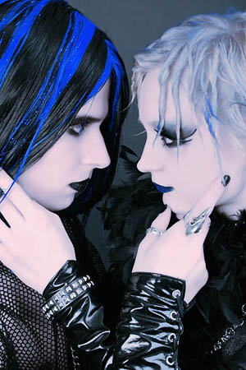
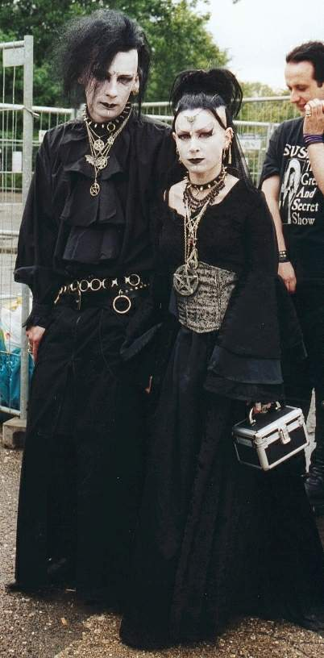
Goth.Along with the evolution in style towards a more genteel look, people also started to look back to 18th/19th century "gothic" styles in literature and dress. This was probably largely a result of the scene having been labelled "gothic", and is an interesting example of the effect a label can have upon a scene. They like to wear black hair, clothes, shoes and metal chain.

In the mid-60s the Mods (so called because of their modern style of dressing) became the new leaders of teenage fashion. Short hair and smart suits were popular again. The Mods rode scooters, which they usually decorated with a lot of lights and mirrors. They often wore long green coats with hoods, called parkas.
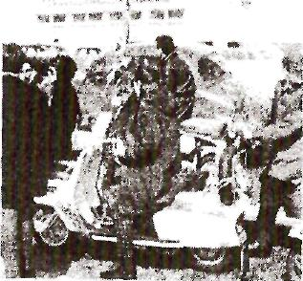
The Mods' greatest enemies were the Rockers, who despised the Mods' scooters and smart clothes. Like the Teddy Boys, Rockers listened mainly to rock-n-roll. They rode powerful motor-bikes, had long untidy hair, wore thick leather jackets, and drank alcohol.
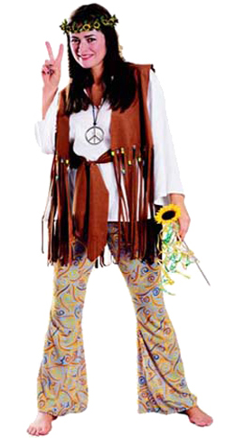
Hippie
Many decades ago our distant predecessors already began to search for alternative views on the life, on the surrounding us society and the world as a whole. Still then, in the middle of 20 centuries, these new forms of world view began to leave to the surface, materializing in the entire youth flows. Thus, perhaps, by quite global flow among the young people of the middle of past century were motion hippies.


Emo. Faces are chalky white, eyes and lips black. You can wear any colour you like so long as it's black. The Emos - short for Emotional - regard themselves as a cool, young sub-set of the Goths. Although the look is similar, the point of distinction, frightening for schools and parents, is a celebration of self harm. The Emos exchange competitive messages on their teenage websites about the scars on their wrists and how best to display them. Girls' secondary schools have for some time been concerned about the increase in self harm.

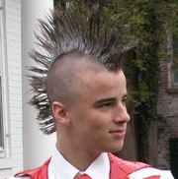
PunkGoth evolved from punk. Most of the important early goth (or "gothic") bands - the Banshees, Joy Division, UK Decay- had at one point been punk bands, and something of the spirit of punk passed into the early goth movement. By 1981, British punk had devolved into two main groups: Oi! and the anarcho movement centred around Crass. Neither side had much to offer musically, and some journalists looked to rising goth bands like Southern Death Cult as keeping the spirit of punk alive. Hence the tag Positive Punk which was applied to some of these bands. Musically, many of the early goth bands differed from punk in that they'd discarded the use of buzz saw guitars, instead using tribal drums with shards of guitar thrown over the rhythm section. The lyrics and imagery were also changing, tending towards the dark and morbid rather than the straightforward and political. However, there was no clear dividing line, and many of the early goth bands played with and/or shared labels wirth punk bands.From a fashion point of view, goth still shared much in common with punk, particularly as regards spiky hair, ripped clothing and mohawks (though the classic goth mohawk tended to be black and a lot wider). Since the Banshees were for a while still regarded as a punk band, the "Siouxsie-clone" look was by no means restricted to proto-goth girls, and a lot of the early gig-going crowd looked a lot more punk than goth.As regards contacts between the subcultures, for a long time goth was part of punk, and it was a while before it became a subculture in itself rather than a subdivision of punk. After about 1983, however, goth had emerged as a separate subculture and became increasingly separate from punk in both music and style.
Futurist The Futurist scene, such as it was, is very hard to pin down, even more so than goth. Essentially, though, it was a short-lived media-defined musical scene centred around avant-garde electronic music. It's worth mentioning here as there was some degree of musical crossover with the emerging goth scene.The "Futurist" tag appeared in September 1980, as follows:From George Gimarc's Post-Punk Diary for Monday September 15 1980:STEVO the DJ at Billy's club and general provider of the soundtrack to the new scene brewing in the electronic underground, has his top 20 current records list published in Sounds under the heading "Futurist Playlist". Top tracks are Joy Division "Isolation", Gary Numan and "I Die You Die", Bowie's "Ashes to Ashes", Bauhaus with "Terror Couple Kill Colonel" and Gina X and "Do It Yourself". At #6 is Fad Gadget and "Fireside Favourite", B-Movie with "Soldier Stood Still", Gary Numan's "Aircrash Bureau" and "Telekon", and a demo from Blancmange of "I've Seen The Word". Other groups present are Modern English, Pere Ubu, Throbbing Gristle, Human League, YMO, Iggy Pop and Last Dance. Several months from now Stevo will confess to the NME that "...the tag Futurist is a bunch of crap. I took a chart of the most popular electronic music I was playing as a DJ into Sounds and said to them 'put it in but don't call it 'Eurorock' or anything like that'. I grab hold of the paper a week later and it says 'Futurist'. I hate all this stopid tagging."Despite Stevo's disclaimer, "Futurist" was seen by some as a useful tag for an emerging movement, and there were actually "Futurist" nights at some nightclubs. The movement was seen by some as an avant-garde version of/reaction to the "pop" New Romantic scene, with the most important bands being John Foxx-era Ultravox and Gary Numan. However, the movement seems to have suffered from the lack of a coherent identity and never became a subculture as such.The tag, however, became popular for a while- in an interview in Sounds in January 1981, Blancmange denied being Futurist ("I'm not a Futurist. I hate that word. What we do is more like experimental new music") whilst Depeche Mode laid claim to the term in an attempt to evade a worse one ("OK, we're Futurists. We've always been Futurists. For me, Futurusts were an extension of punk rock. We never had anything to do with New Romantics. They all looked the same. Bunch of flaming sissies! But call us what you like. Ultra pop. Fiturist, Disco. Anything so long as it’s not New Romantic").
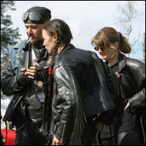
Metal. In the context of a history of the early goth scene, having a section about Metal is about as relevant as having a section about Mod or Ska. All three scenes were around (in a revived form) at roughly the same time as the early goth scene, but they had very little interaction with or influence upon it.However, an awful lot of people seem confused on this point, so maybe I'd better explain.The late 70s and early 80s were very different to what came later - even just a few years later, when goth took on rock influences and rock became fashionable again.At the end of the 70s and start of the 80s heavy metal, as one of the many things punk had been reacting against, was deeply unfashionable. Goth came from punk roots (with influences from Bowie and co as described elsewhere) and largely inherited this deep-rooted contempt of all things "metal". Metal was regarded as archaic and a thing of the past, whereas most early goth bands saw themselves doing something new, fresh and in some cases experimental. Later on, metal was to absorb influences from goth, punk, industrial and even rap, but at the time the most that could be said of it was that the impact of the punk revolution had resulted in a somewhat harder sound (later on, punk influences on the likes of Metallica would completely change metal, but that's a different story).Certainly in the early 80s the two scenes were poles apart, in both music and fashion - goth was darkly glamorous, with an androgynous look, lots of makeup and fishnets, whereas the metal scene was still largely biker chic, with denim and patches. Essentially, goth had a feminine edge whereas metal was still very masculine. As for rock influences, I can only think of two early bands who were overtly influenced - Play Dead (Black Sabbath) and The Sisters of Mercy (Rolling Stones, Led Zeppelin). Neither were major players in the early scene, though the Sisters were later to be partially responsible for the shift to Goth Rock. It should also be stressed that those rock influences were simply one of many, for both groups (the Sisters were just as much influenced by, say, Leonard Cohen), and that neither group had contact with the contemporary metal scene.

Ravers are folks, who use a computer made, synthesized music, and drugs to create massive dance parties in empty warehouses. They like to be in a collective. They want to try out all sort of options and are thought to be violent and rebellious.

Psychobilly. Psychobilly was a bizarre mutant hybrid of punk and rockabilly which emerged at roughly the same time as goth. It's worth mentioning here because there was a certain amount of crossover between the two emergent subcultures- some bands such as Alien Sex Fiend, Sunglasses After Dark and the Cramps appealed equally to goths and psychobillies, and some of the "punkier" goths had psychobilly leanings.For further background, here's the article on Psychobilly from Ted Polhemus' "Streetstyle". At first glance it is hard to imagine a more unlikely combination than Punk and Rockabilly, but the Psychobillies made a virtue of such apparent incompatibility.
What do elderly and middle- aged persons think about teenagers?
1) More violence, more vandalism* exists than it did ten years ago.
Many people say that their lives have been made miserable by young
people out on the street late at night. Young people are more violent
than ever. All those groups or subcultures are awful, because all of
their members are violent. They only think about rebellion against society, its laws, they reject everything, they protest against their parents
and school. I think they are potential criminals, their groups are like
gangs (банды). I think all these groups should be forbidden.
2) Violence is the symptom of problems in the society. Teenagers
don’t live in a desert. Home, school, and neighborhoods are part of
the individual environment. They play a great role in the expression of
violence. A society cannot suggest anything really worthwhile for
teens. There are not many organizations that are interesting for teens.
There are not enough sports clubs. Besides many hobbies and sports
are expensive, and teens can’t afford them. That’s why they are rebellious. Crime for teens is an expression of their inability to join in society. At different levels: social, economic or cultural. Teens don’t think
much about their future life. They want to live now. Being in a group
is like living a real life for them. To be a fan of something or some*
one is a hobby, to be a hippie, for example, it is life.

What think teenagers about them?
It seems to me that media makes the situation worse. The bad image of youth groups is presented by the press. These groups are not that bad as they are thought to be. Teens want to show off. Hut at the same time a lot of teens think about changing the world for the best. They help people around them. They help nature. I am sine, teenagers will become good citizens. Some who were punks became editors of famous newspapers. And I know a person who was a hippie and some years later became a president of a big country. A subculture is a way of life. It is not a fan club; it is a real life for teens.
Our ideas.
We have many ideas in organization the museum about young subcultures in our school and we think that it is very interesting. Because young people have a particular relationship with the world. There are many groupings (or subcultures) that have interests different from those of the mainstream culture. A particular cultural grouping is a way for young people to express their individuality. Most young people create a certain lifestyle within their subcultures. Why do they do it?
- to express themselves
- to express their own identity
- to develop their own style distinct from others
- just to show off
- to identify with a particular subculture
- to know who they are
- to support a certain attitude and lifestyle
- to change the world to the best
- to protest against the parents
- to try out all sort of options
- to rebel against the society
- to reject everything
- to be in a collective
- to differ from social norms
- to be designed to shock
- to have their own values and beliefs
- not to conform to society standards
We think that school museum can help some people to understand their children or other young people and it will give them the ideas of young people. We think that school has a lot of places, such as the wools. At first we decided to do social interrogation about this museum. A lot of people think that it will be very interesting museum and they want to help us. They suggest us very interesting ideas.
Как мы уже говорили, нам было подано несколько интересных идей и некоторые из них были приняты нами для воплощения их в реальность. Люди старшего поколения говорят, что если бы их внуки пригласили их в музей молодёжных субкультур, они бы охотно согласились. Неужели не интересно узнать, чем живёт нынешняя молодёжь? С их стороны, на наш взгляд, поступило замечательное предложение о том, чтобы собрать информацию о жизни молодёжи их времени (о пионерах, скаутах…) и они согласились рассказать нам о своих увлечениях. Кто-то даже вспомнил о произведении Гайдая «Тимур и его команда» и посчитал необходимость создания такой группы. Может, кто в музеи заинтересуется?
Практически вся молодёжь считает, что были бы ни прочь посетить такой музей, но для начала его стоило бы проафишировать, т.е. прорекламировать.
Конечно, нашлись такие люди, которые посчитали это бесполезным занятием.
After socialist interrogation we began to gather the information’s. It will be not a big place with exhibits, newspapers and photos. A lot of parents can know more about their children and will can to find common language.
Сейчас мы хотим на русском языке рассказать о трудностях и весёлых моментах, которые возникли у нас во время размышлений над организацией музея.
Для начала мы захотели узнать, как это быть готом, эмом или ещё кем-нибудь. Мы одевались, красились как они и даже несколько раз запечатлели это на снимках (приложение, фотогалерея). Конечно, возникали трудности во время подбора одежды, косметики, украшений. Но с этим мы справились, хотя считаем, что группировщики из нас никудышные. Также мы раздумывали о фотовыставках, экспонатах или просто об организации уголков о различных субкультурах. Мы пришли к единогласному решению, что на первое время можно создать фотогалерею. По нашим задумкам она содержала бы не только фотографии, но и одежду, небольшую информацию о каждой субкультуре. Мы думаем, что именно так можно привлечь учащихся к какой -либо помощи по созданию музея. Это, возможно, добровольная помощь в оформлении, сборе фотографий, каких-то экспонатов, одежды и другом.
We think that our project will be interesting for you and you will support us .

Заключение.

Итак, теперь мы хотим подвести итоги нашей деятельности и объединить наши предложения.
- Местом для музея могут послужить стены и фойе школы.
- Практическая деятельность:
- стенды для фотографий;
- макеты одежд;
- информация о субкультурах для учащихся в устном и электронном виде;
- создание презентаций о различных субкультурах.
- Реклама музея:
- в виде Интернет-сайтов;
- в виде афиш.

Нам кажется, что наши задачи успешно выполнены и мы готовы к осуществлению наших идей.

Список используемой литературы

- Английский журнал «English. Preparing for Exams» 2/2008
- Английский журнал «English» 14/2006
- Учебное пособие «Великобритания»
- В.П. Кузовлев, Н.М. Лапа, Э.Ш. Перегудова, И.П. Костина, О.В. Дуванова, Е.В. Кузнецова, Ю.Н. Балабардина « English 10-11» student's book, activity book, reader
- Ресурсы Интернета

Приложение
Социологический опрос
- Как вы относитесь к молодёжным субкультурам?
- Что они собой представляют?
- Что вам известно об отдельных представителей субкультур?
- С чем у вас ассоциируются определённые субкультуры?
- Как вы относитесь к идеи создания музея молодёжных субкультур?
- Как вы себе представляете музей молодёжных субкультур?
- Как вы думаете, стоит ли открывать такой музей?

История изучения молодежных субкультур
Ненормативное (отклоняющееся от принятых в обществе норм, асоциальное) поведение молодых людей впервые стало объектом внимания ученых в Соединенных Штатах Америки в 30-50 гг. XX века. Ученые-социологи, психологи, правоведы изучали возникновение и функционирование молодежных банд в больших городах, в первую очередь Чикаго (многие из вас вспомнят имевший шумный успех американский фильм «Банды Чикаго» с любимцем девушек всего мира Леонардо ди Каприо в главной роли). Здесь рассматривалось ненормативное (то есть нестандартное с точки зрения общественных норм) поведение молодежи. Фильм, естественно, в силу специфики жанра несколько романтизирует образы и ситуации; исследователи же анализировали их причины и суть. Исследования показали, что члены таких бандитских объединений живут в соответствии с собственными правилами и нормами, которые являются отклонением от базовой социально-культурной нормы. Именно к ним, этим объединениям, и было впервые применено понятие «субкультура». В этой концепции субкультурой является такое сообщество, где нетипичное («асоциальное») поведение рассматривается как конформизм, то есть норма. Субкультурой стали называть такую подсистему общества, которая не признается обществом в целом, в первую очередь государственной властью.
Как видим, первоначально подход к субкультурам был чисто социологическим. Затем интерес к этому феномену перемещается в более широкую сферу гуманитарных интересов — сферу культурологии.
После второй мировой войны термин «молодежная субкультура» вошел в обиход социологов и стал употребляться не только применительно к преступным формированиям, но и ко всем явлениям культуры, связанным с молодежью. Отмечалось, что рост благосостояния ведет к повышению покупательной способности молодежи, а это в свою очередь порождает возникновение нового, самостоятельного рынка товаров и услуг, ориентированного на молодого покупателя. Это было названо «прорывом тинэйджерской культуры». Впрочем, в этот период отклонения от базовых норм и ценностей общества у молодежи было незначительным и многие исследователи на этом основании отрицали существование понятия «молодежная культура», аргументируя свою позицию тем, что в руках старшего поколения сосредоточены мощные средства влияния и контроля над образом жизни молодого поколения.
Молодежная субкультура постепенно дифференцировалась, в ней возникли различные движения, которые связывались уже не только и не столько с модой и музыкой, сколько с общественно-политическими взглядами — этот процесс охватил культуру в 60-70 гг. Тогда и заговорили о «конфликте поколений», а как следствие резко возрос интерес к исследованиям, изучающим эту проблему.

Как тинэйджеры выражают свою индивидуальность сегодня?
Одним из главных выражением своей индивидуальности является объединение в различные группы.
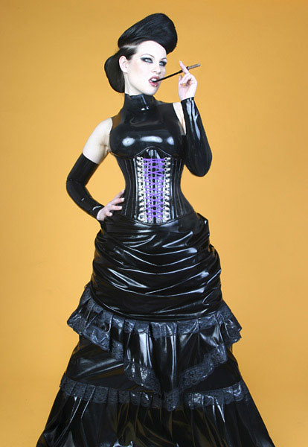
Готы. Среди них различают несколько течений: классические готы, гот – вампы, Punk Goth, Victorian Goth, Androgyn Goth, Hippie Goth, Corporate Goth, Cyber Goth и другие. Все они предпочитают чёрный цвет ( кроме Victorian Goth), цвет волос отличается в зависимости от принадлежности к группе, носят ошейники, напульсники и английские булавки.

Моды. Быть Модом - значит иметь пару тяжелых ботинок. Наиболее распространенной формой Модов являются отбеленные джинсы с красными подтяжками, тяжелые красные ботинки со стальными носками. Они также носят одежду Levis коричневого вельвета или защитного цвета. Обладатели скутеров носят Парку с "Дэйв Дэйдженхэм" на спине. Моды отличаются безразличием, вплоть до полного игнорирования, к рок-н-роллу.
Хиппи. Все хиппи носят длинные распущенные волосы (хайр), обычно расчесывая их на пробор. Лоб и затылок охватывает тонкая повязка (хайратник). Обычно присутствуют джинсы или джинсовая куртка, иногда балахон неопределенного цвета, на шее – «ксивник» (небольшая кожаная сумочка), украшенная бисером или вышивкой. На руках – «феньки» (от англ. thing – вещь), т.е. самодельные браслеты или бусы, чаще всего из бисера, дерева или кожи.
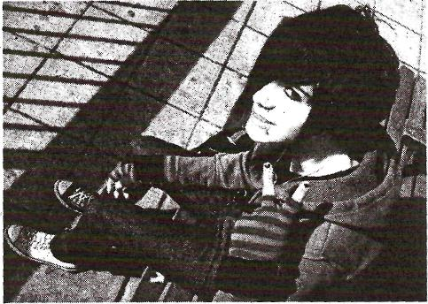
Эмо. Произошло от слова « Эмоциональность». Эмо носят косые чёлки, закрывающие сбоку глаз, любят сочетание розового с чёрным, подвержены эмоциям. Их зачастую называют плаксами из-за их слишком проблематичного отношения к жизни.

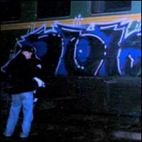
Граффити. Жизнь граффитчиков далеко не такая беззаботная и пустая, как кажется многим противникам данного искусства. Нелегальное бытие райтеров приводит не только к постоянным скандалам с родителями, грубым оскорблениям прохожих, непониманию со стороны любимых и друзей, но и к конфликтам с представителями правопорядка, а это уже посерьезнее несовпадающих взглядов на искусство. В граффити очень важно самовыражение и поиск своего собственного стиля.

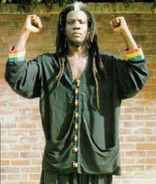
Растманы. Во внешнем облике, помимо маек с листом каннабиса, беретов, вязаных балахонов и шапок (самодельных) расцвеченных красно-желто-зеленым (цвета флага Эфиопии), у растафари имеются и другие знаки отличия. Например, расточки. Это несколько длинных волосков с вплетенными в них нитками, камушками, шариками или еще чем-нибудь и, конечно же, дреды - длинные локоны, заплетенные в косички, натертые воском для волос и скрученные в плотные тяжи.

Фурри .Что же такое "фурри"? Есть множество интерпретаций этого слова, но для того, чтобы дать наиболее подходящую, следует сказать, что Фурри, иначе фёрри (от англ. furry) — это субкультура, которая объединяет людей, так или иначе интересующихся антропоморфными животными в изобразительном искусстве, анимации, художественной литературе и дизайне. Особенностью субкультуры является стремление её представителей к воплощению образа антропоморфного животного в творчестве или в себе, посредством идентификации с ним. Антропоморфными животными являются сказочные животные, то есть вымышленные существа, сочетающие в себе качества человека и животного как в анатомическом, так и поведенческом плане. Иными словами, "фурри" - это изображения животных, ведущих себя как люди. Человеческими качествами наделяются, в основном, хищники — львы, гепарды, лисы, волки, а также грызуны. Эти звери покрыты мехом, поэтому в англоязычной части субкультуры их прозвали «пушистыми» (furries). Это слово привилось и определило название субкультуры.

Рэйверы."Рейв" (от англ. rave - бредить, бред, бессвязная речь, также: неистовствовать, реветь, выть, бушевать, говорить с энтузиазмом) трактуется в "Словаре современного сленга" Т. Торна как "дикая вечеринка (a wild party), танцы или ситуация отчаянного поведения". Источником жизненных ориентиров рейверов стал музыкальный стиль, а если точнее - образцы стиля жизни их кумиров, музыкантов. Рейверы в основном берут модель поведения завсегдатаев ночных клубов. Соответственно этой модели образ жизни рейвера - ночной. Их внешность и поведение пропагандируют отход человека от природы. Рэйв - не только музыка, но и яркие синтетические одежды, крашеные волосы (часто экзотически окрашенные в квадраты, круги), особые серьги, феньки, танец. Их жизнь - сплошное развлечение. Развлечение - не только дискотеки, наркотики и прочие удовольствия, но и кинематограф, живопись, реже - театр. Идеология рэйверов базируется на развлечениях и невмешательстве. Они не считают, что деньги им должны обязательно давать родители. Согласны подработать, но там, где не нужно много трудиться, добывая себе на пропитание. В солидной, престижной фирме: за большие деньги - пожалуйста. Это тоже один из дорогих стилей жизни. Он и сейчас очень распространен среди молодежи. Обычно рейверов по-простому называют «тусовщиками». К рэйверам примыкают кислотники. Они тоже носят - экзотически яркие одежды и прически, смысл жизни видят в развлечениях.

Фотогалерея

Это мы.

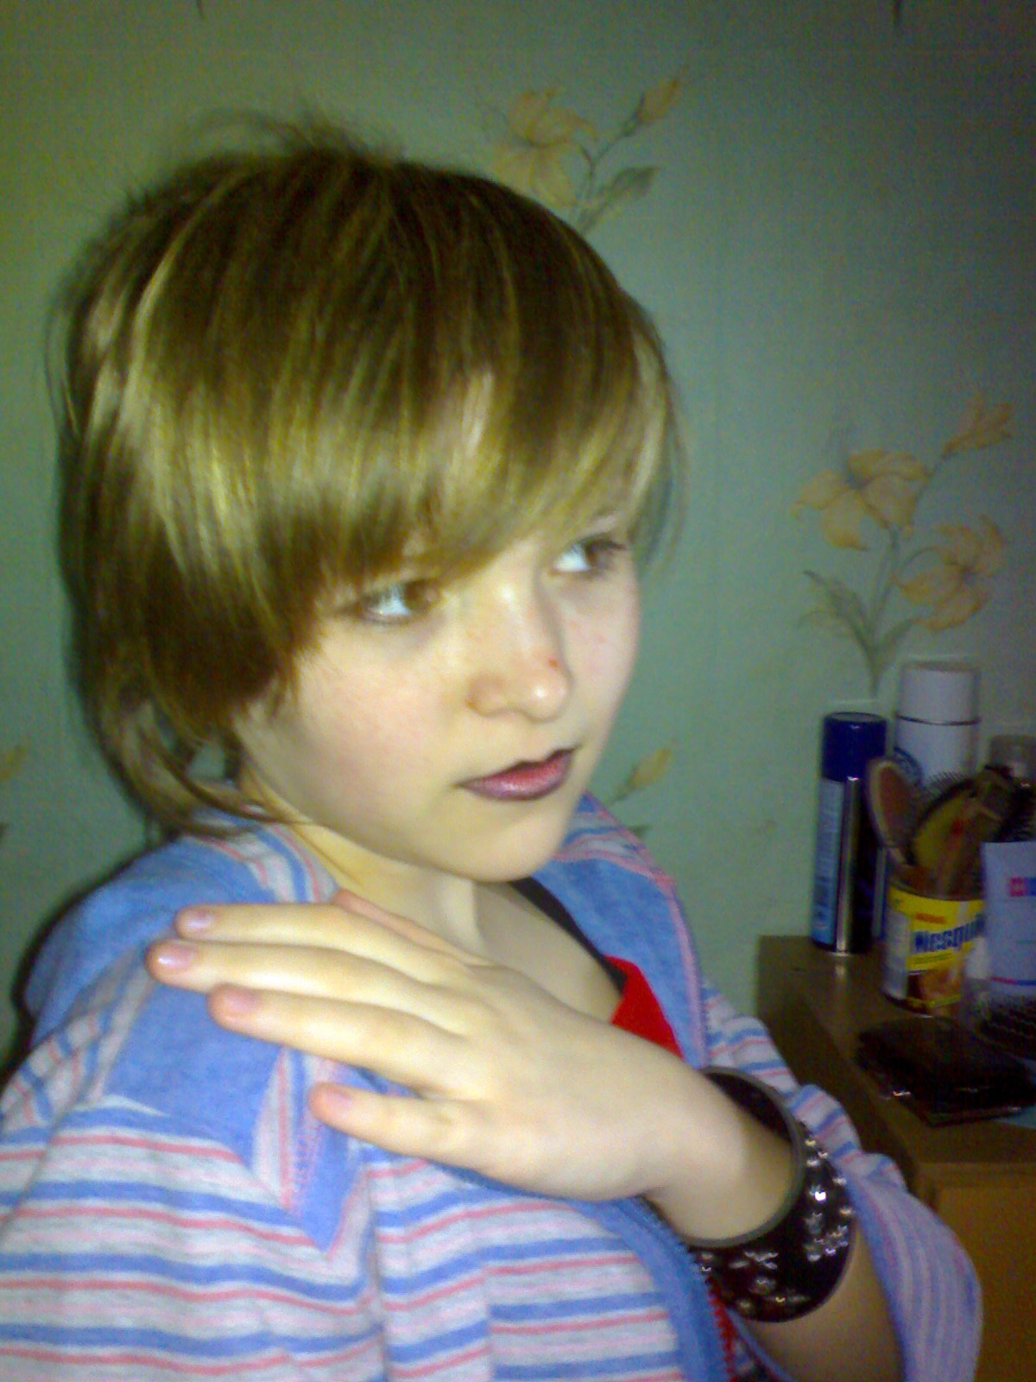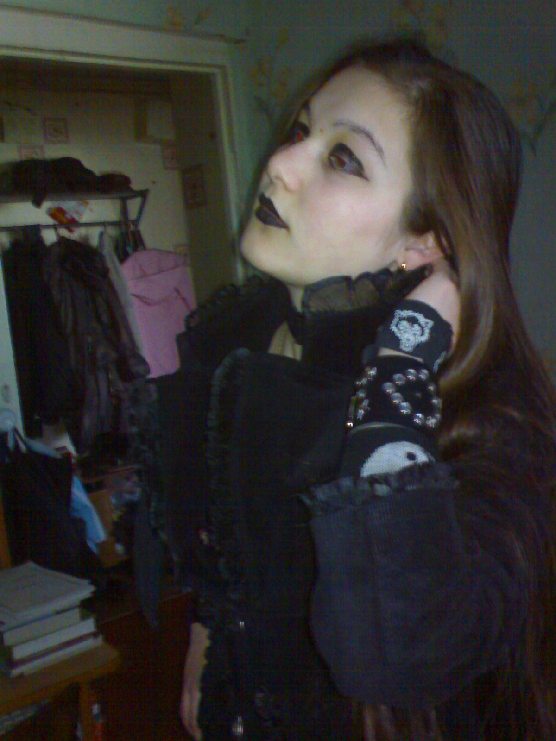

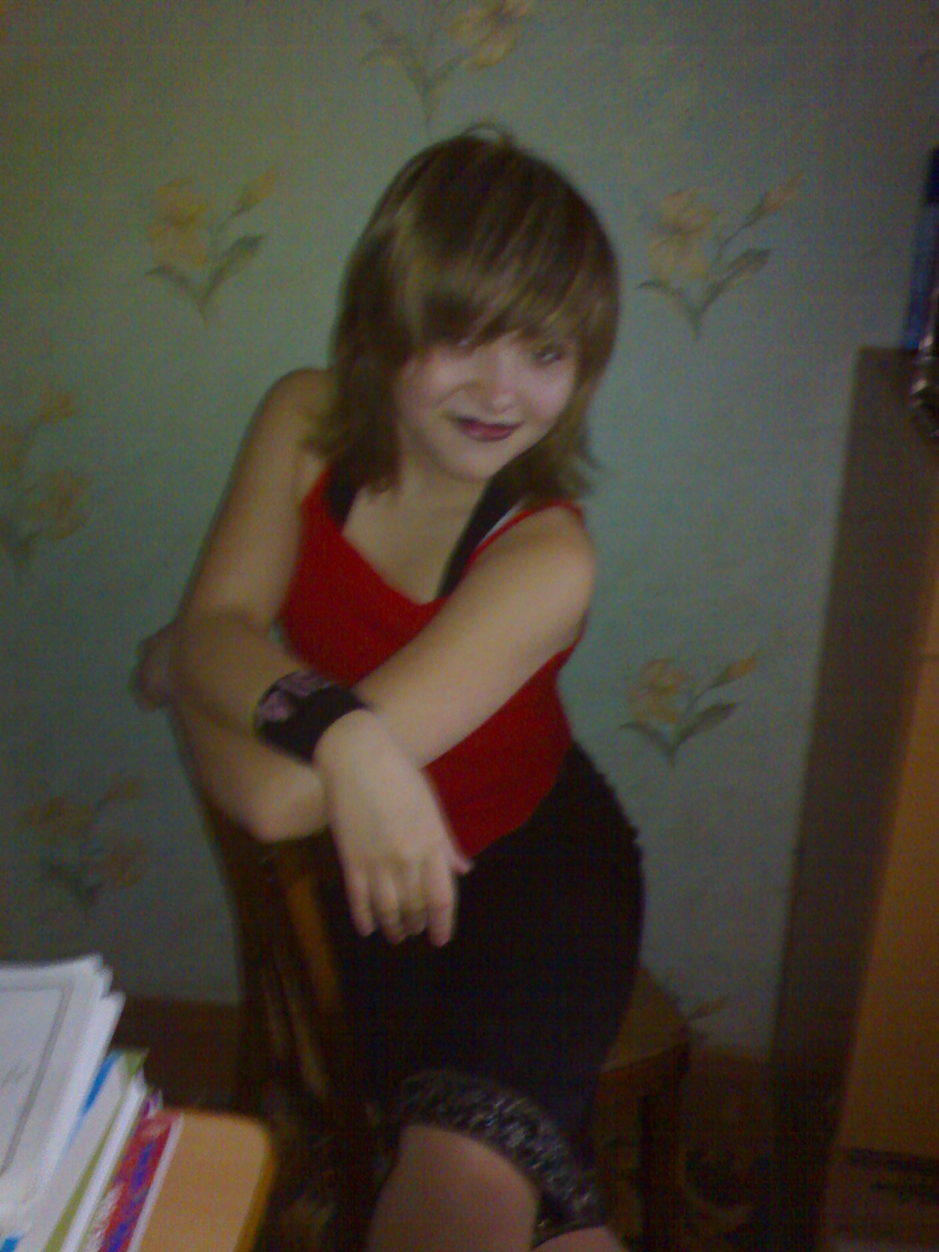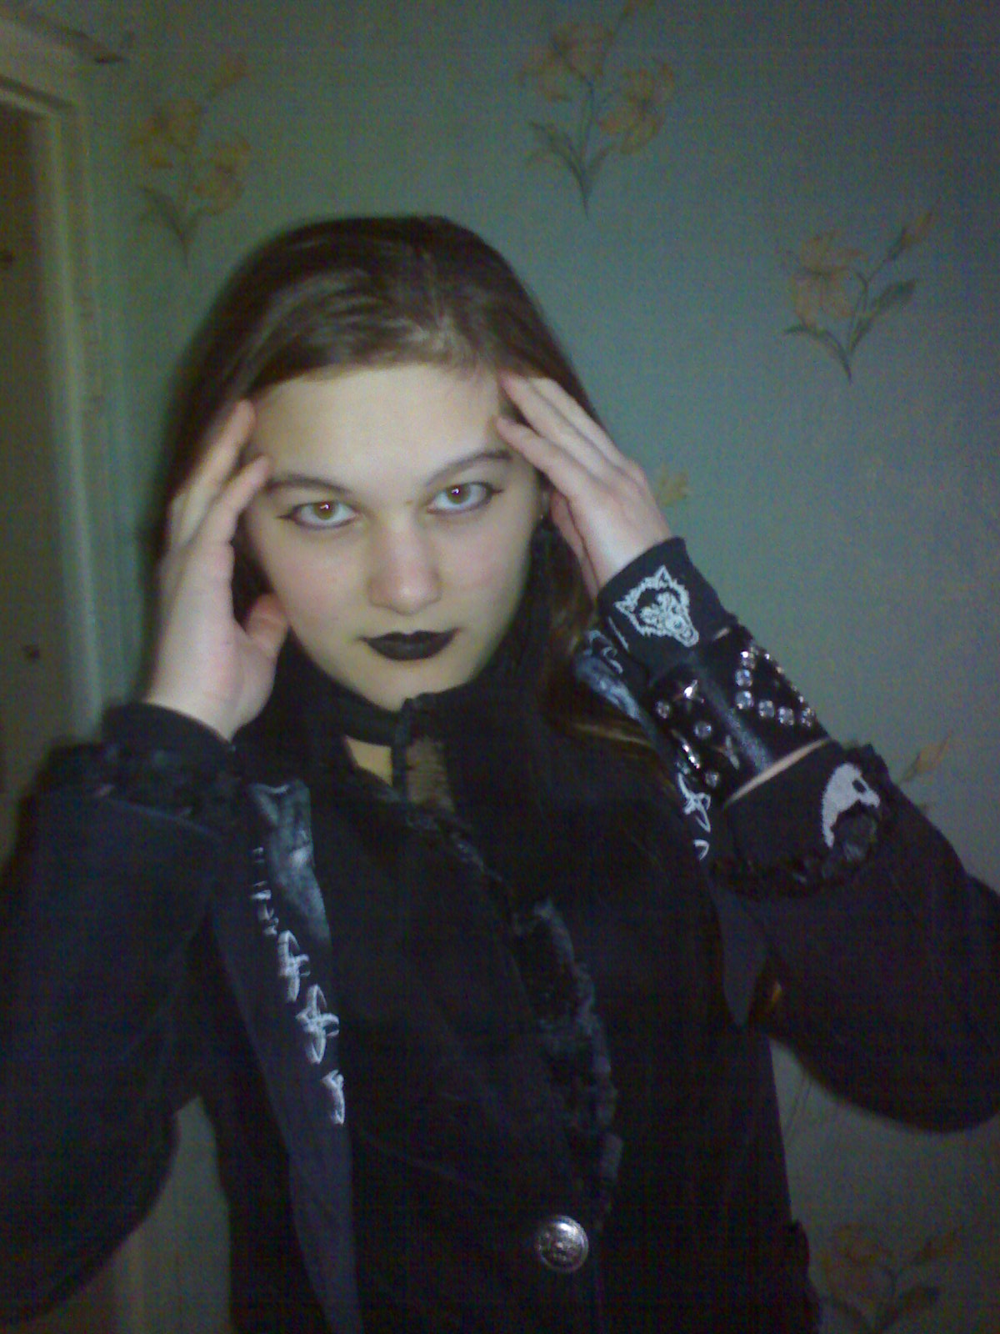

Представители субкультур

Рейверы

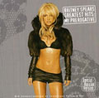

Эмо



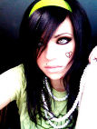



готы

Граффитеры

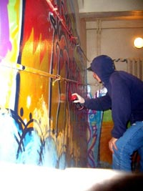

Байкеры

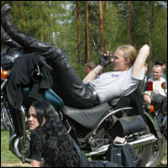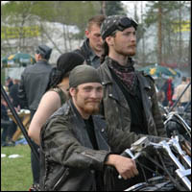

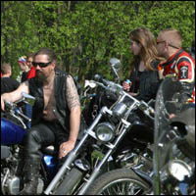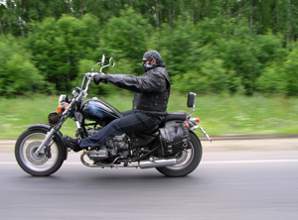

Металлисты

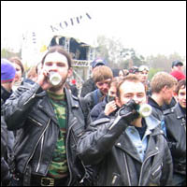

Панки
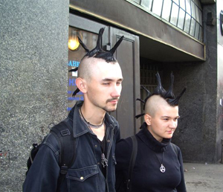

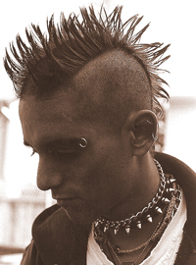

Рэперы

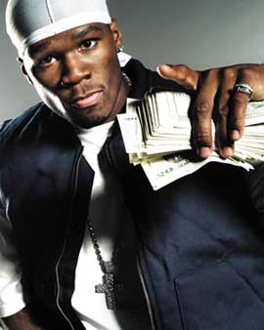

Скинхэды

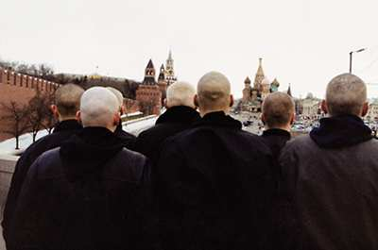

Хакеры и кракеры



Ролевики

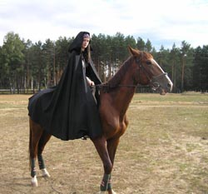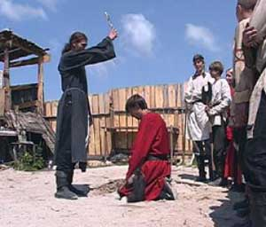

Футбольные болельщики

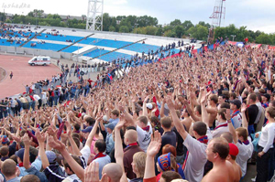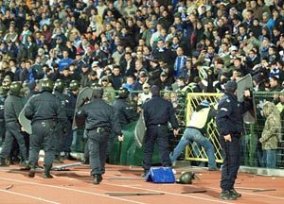

ХИППИ

